Azure Practical No. 01
Deploy a Static Website with Azure Blob Storage
1. Aim
To deploy and host a static website using Azure Blob Storage and verify its accessibility through the Azure Storage static website endpoint.
2. Theory
Azure Blob Storage
- Azure Blob Storage is an object storage service provided by Microsoft Azure.
- It stores unstructured data such as HTML files, images, documents and videos.
- Data is stored as blobs inside containers, and a Storage Account provides the storage environment.
Static Website Hosting
- Azure Blob Storage can host a static website without managing a traditional web server.
- A static website mainly contains client-side files such as HTML, CSS, JavaScript and images.
- When enabled, Azure creates a special $web container where website files are stored.
- Azure provides a Primary Endpoint through which the website can be accessed.
Important Files / Terms
File / Term | Purpose
index.html | Main/default webpage
404.html | Custom page shown when a requested page is not found
$web | Container used to store static website files
Primary Endpoint | URL used to access the hosted website
3. Procedure / Main Tasks
Task 1 — Prepare Azure Environment
- Sign in to the Azure portal and open Resource groups.
- Create/open the required resource group and select the required region.
- Verify that the resource group is available.
Observation: The resource group keeps all resources of the practical together and makes cleanup easier.
📸 Screenshot 1 — Practical Evidence
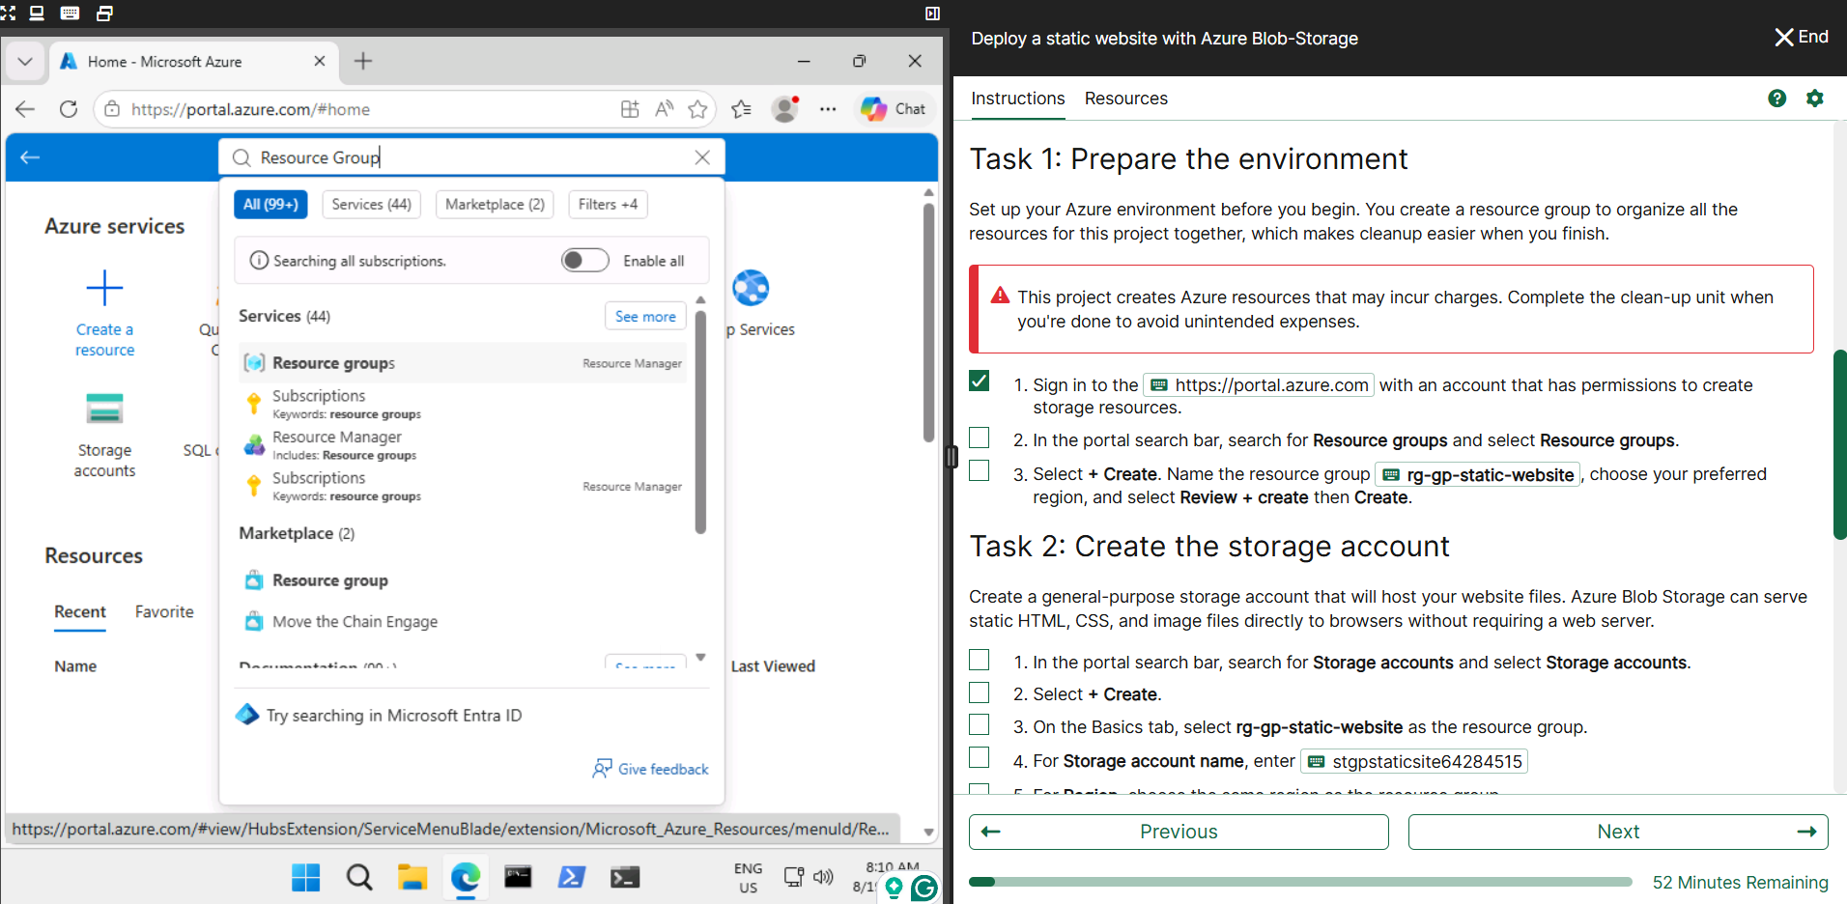
📸 Screenshot 2 — Practical Evidence
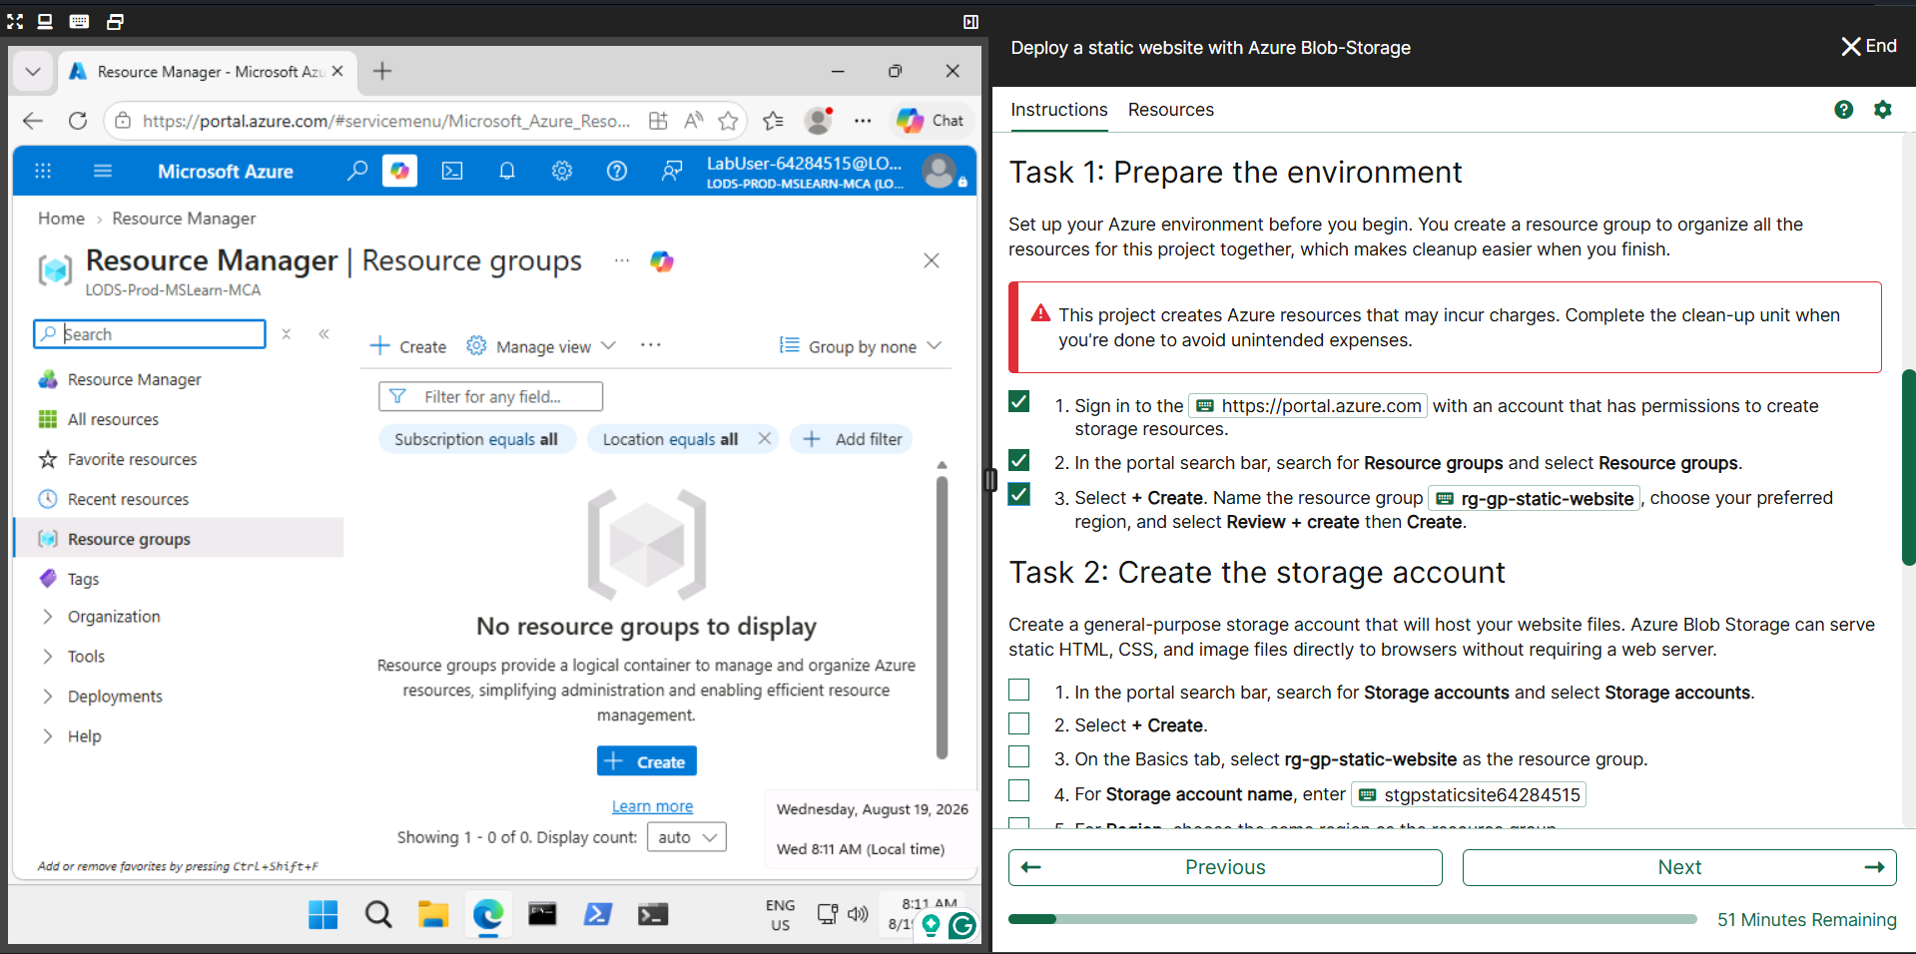
📸 Screenshot 3 — Practical Evidence
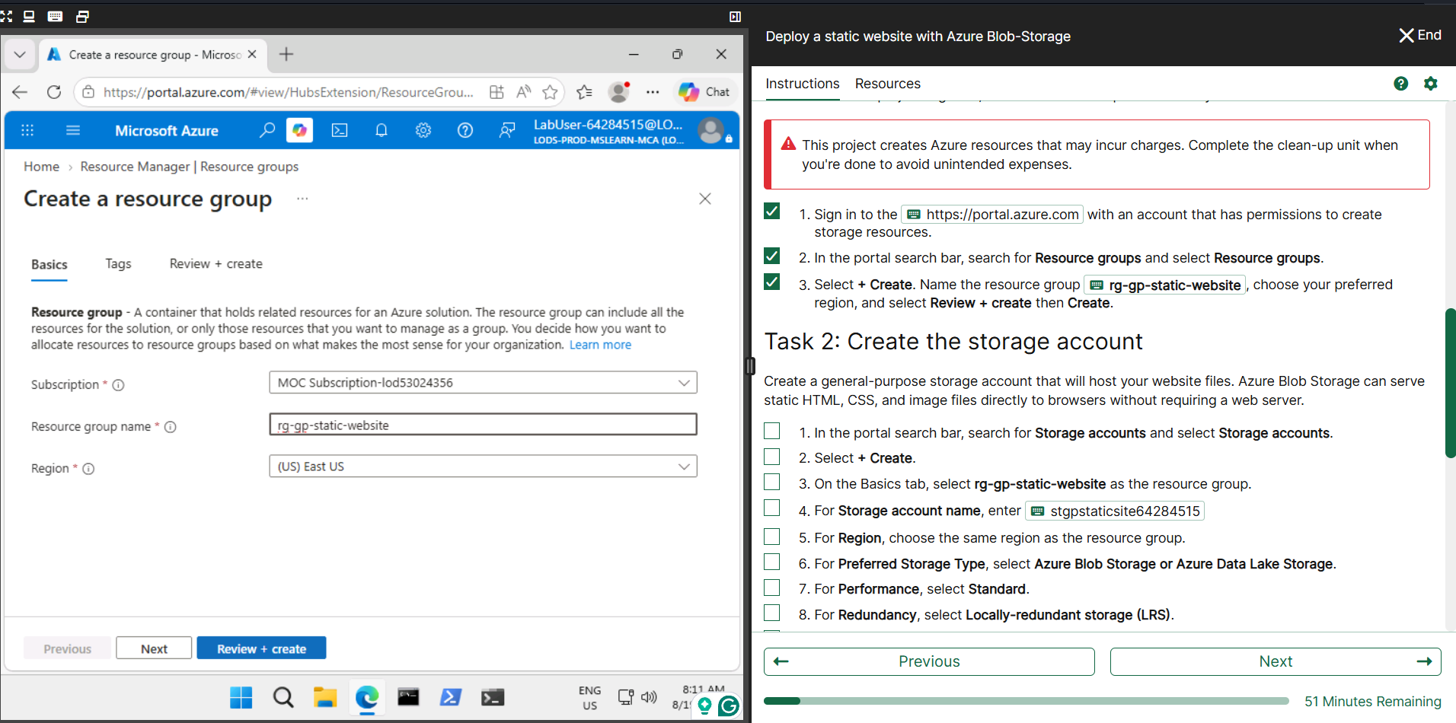
Task 2 — Create Storage Account
- Open Storage accounts and select + Create.
- Select the practical resource group and enter the assigned storage account name.
- Choose the required region and storage configuration.
- Select Review + create, then Create and open the deployed resource.
Observation: The Storage Account provides the environment in which the website files are stored and served.
📸 Screenshot 1 — Practical Evidence
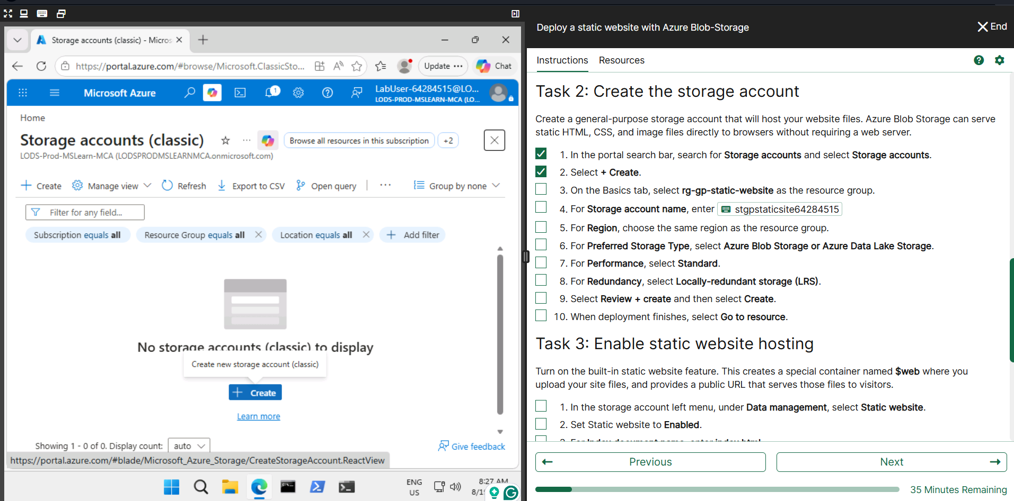
📸 Screenshot 2 — Practical Evidence
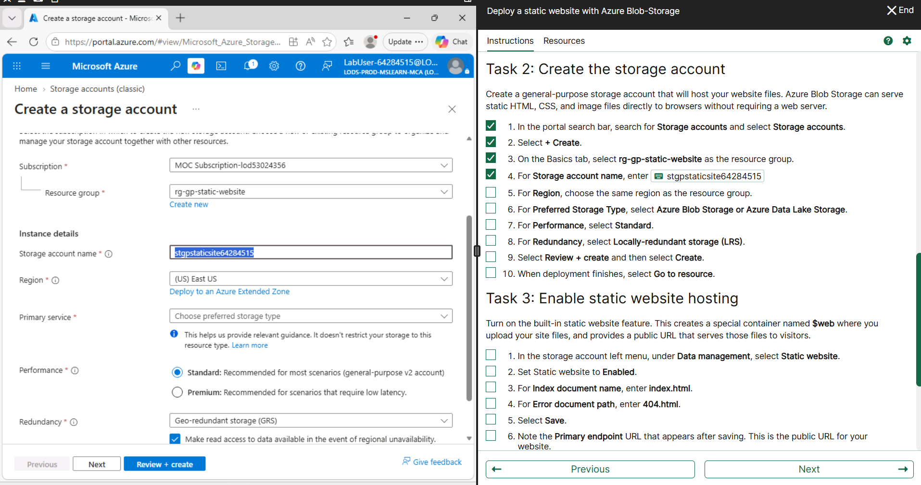
📸 Screenshot 3 — Practical Evidence
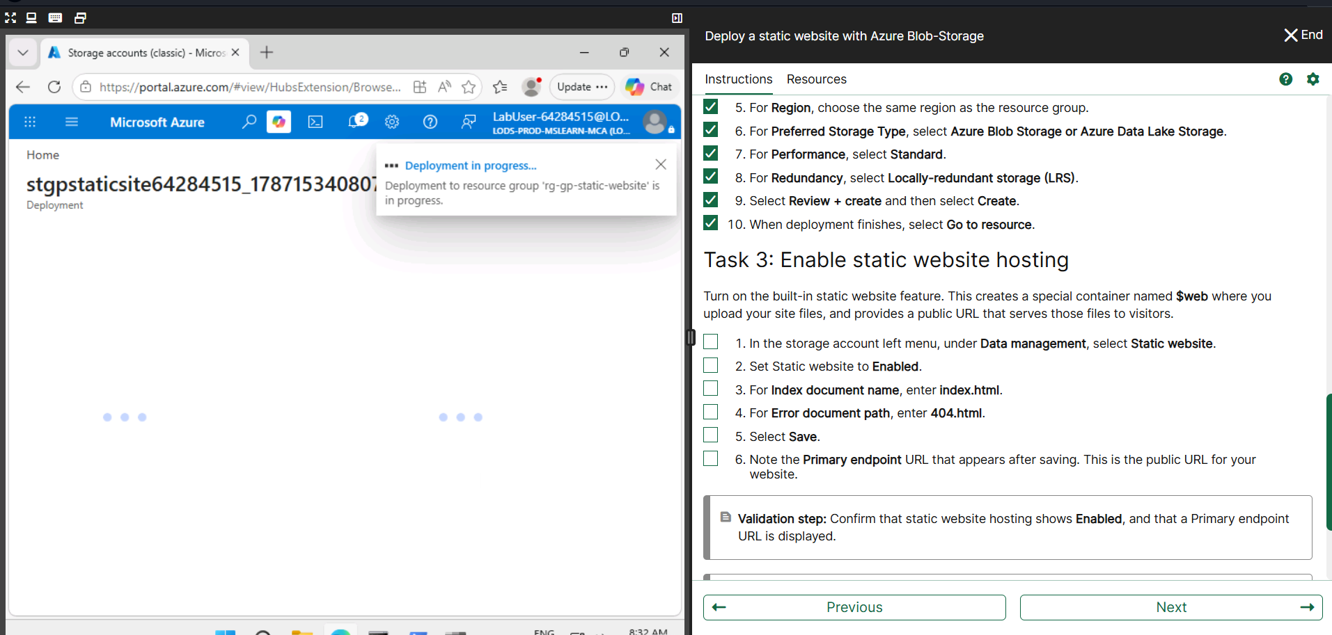
Task 3 — Enable Static Website Hosting
- Open the Storage Account and go to Data management → Static website.
- Enable Static website.
- Enter index.html as the Index document and 404.html as the Error document.
- Select Save and note the Primary endpoint.
Observation: Azure creates the $web container automatically and provides a Primary Endpoint.
📸 Screenshot 1 — Practical Evidence
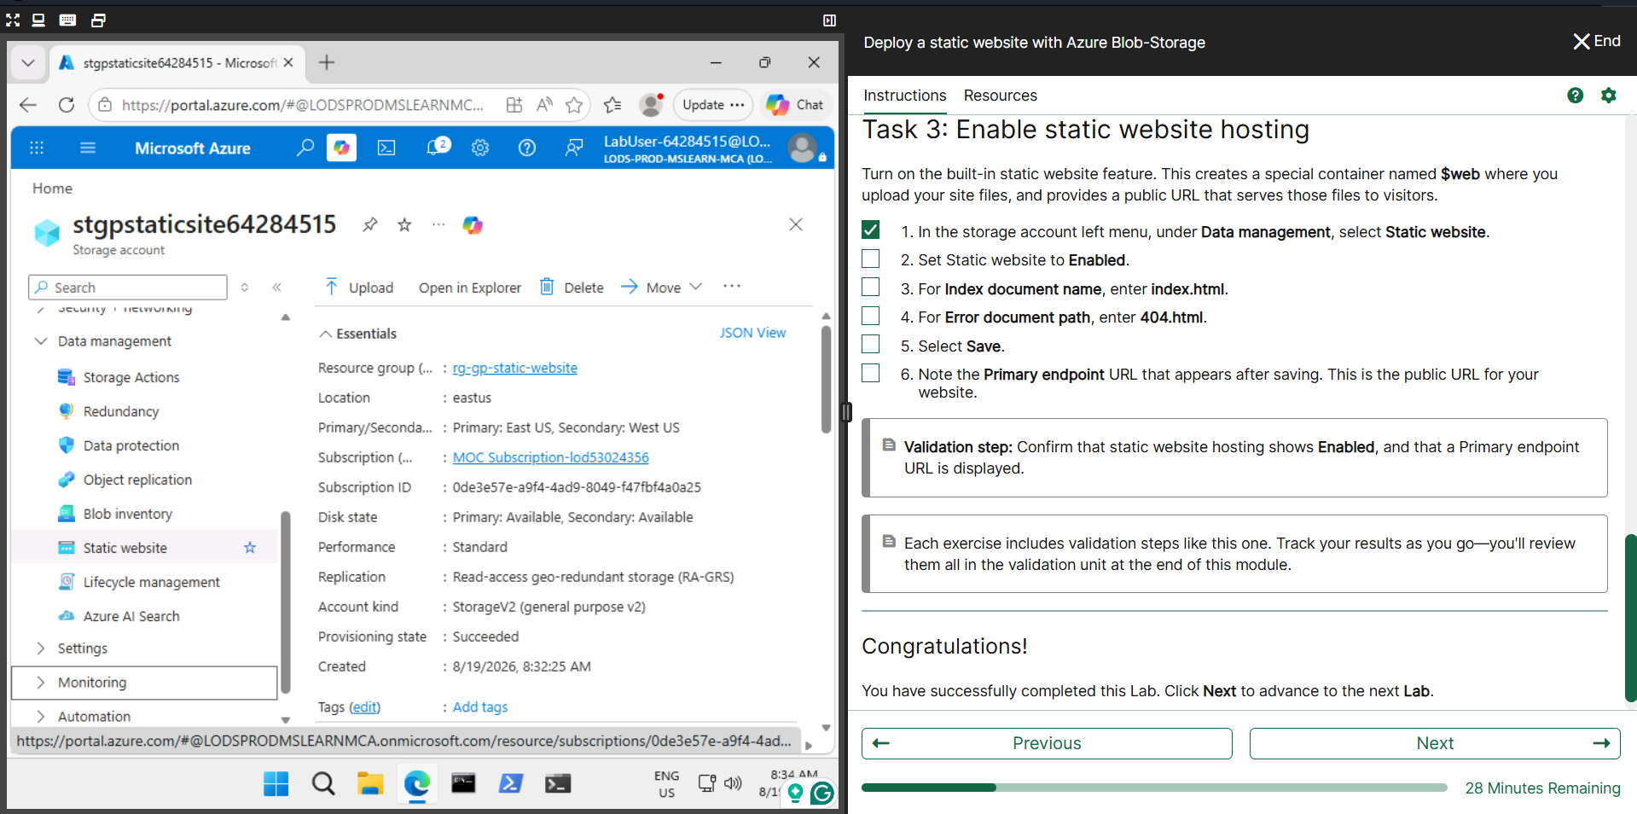
📸 Screenshot 2 — Practical Evidence
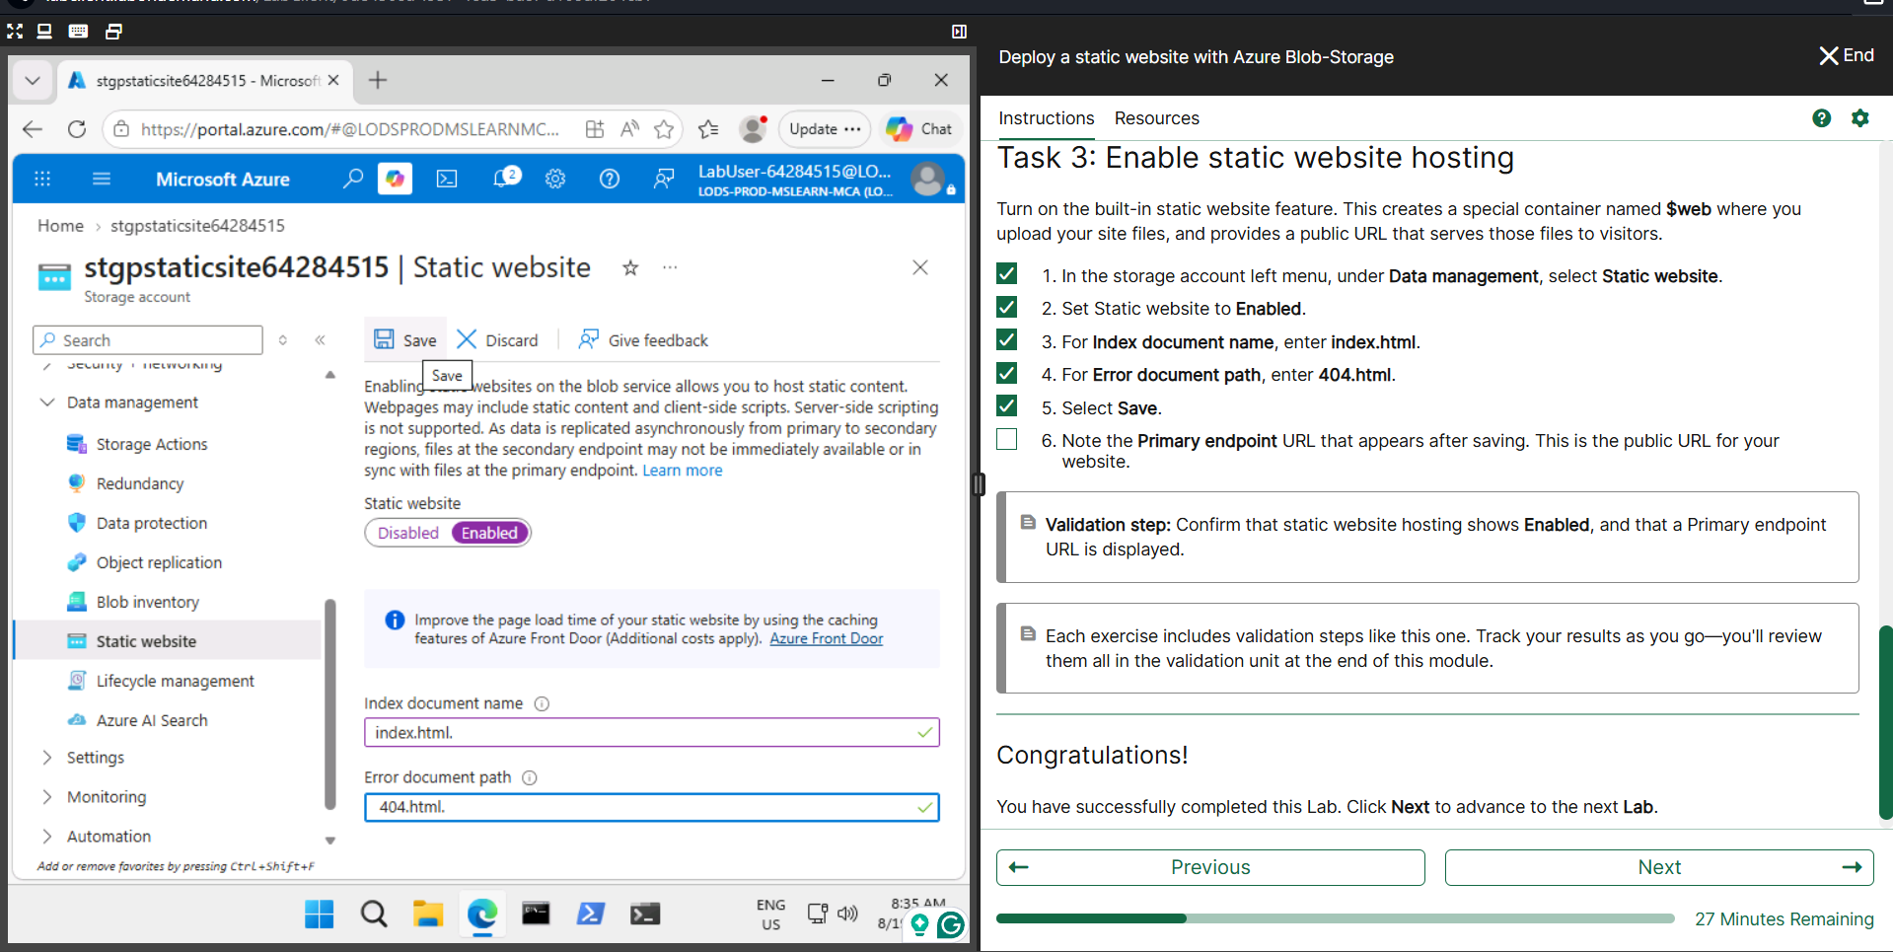
📸 Screenshot 3 — Practical Evidence
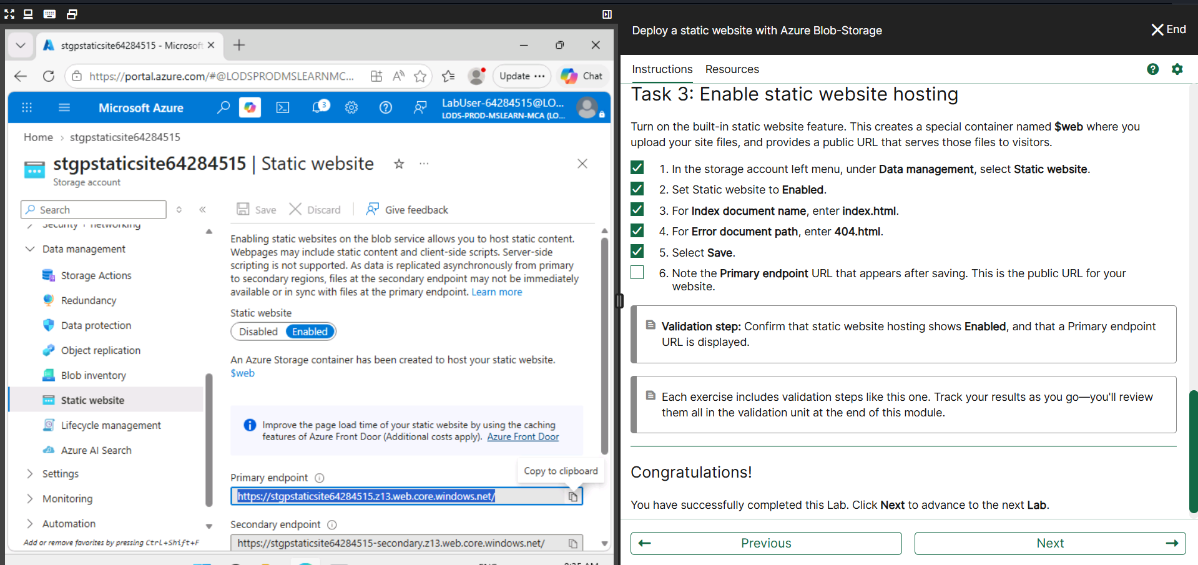
Task 4 — Create and Upload Website Files
- Create and save the main webpage as index.html.
- Create the custom error page and save it as 404.html.
- Open Containers → $web in the Storage Account.
- Upload both files and verify that they are present.
Observation: The $web container stores the files that make up the static website.
📸 Screenshot 1 — Practical Evidence
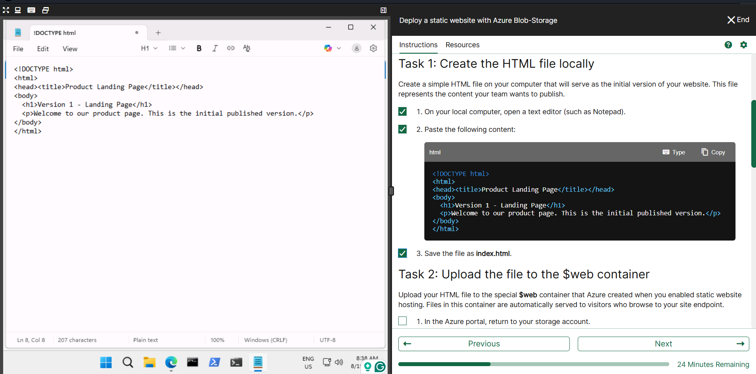
📸 Screenshot 2 — Practical Evidence
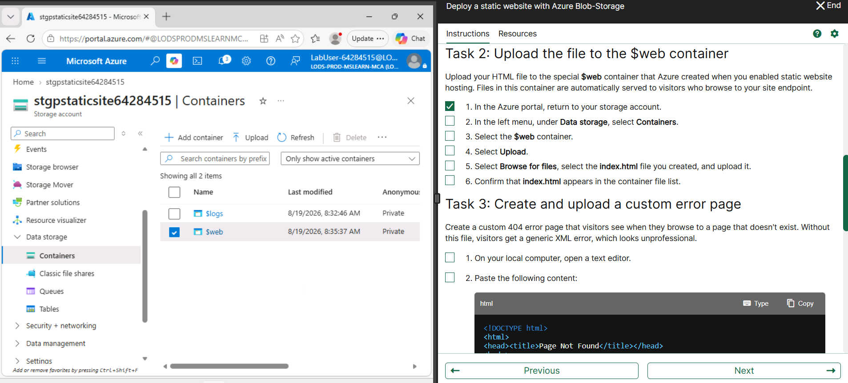
📸 Screenshot 3 — Practical Evidence
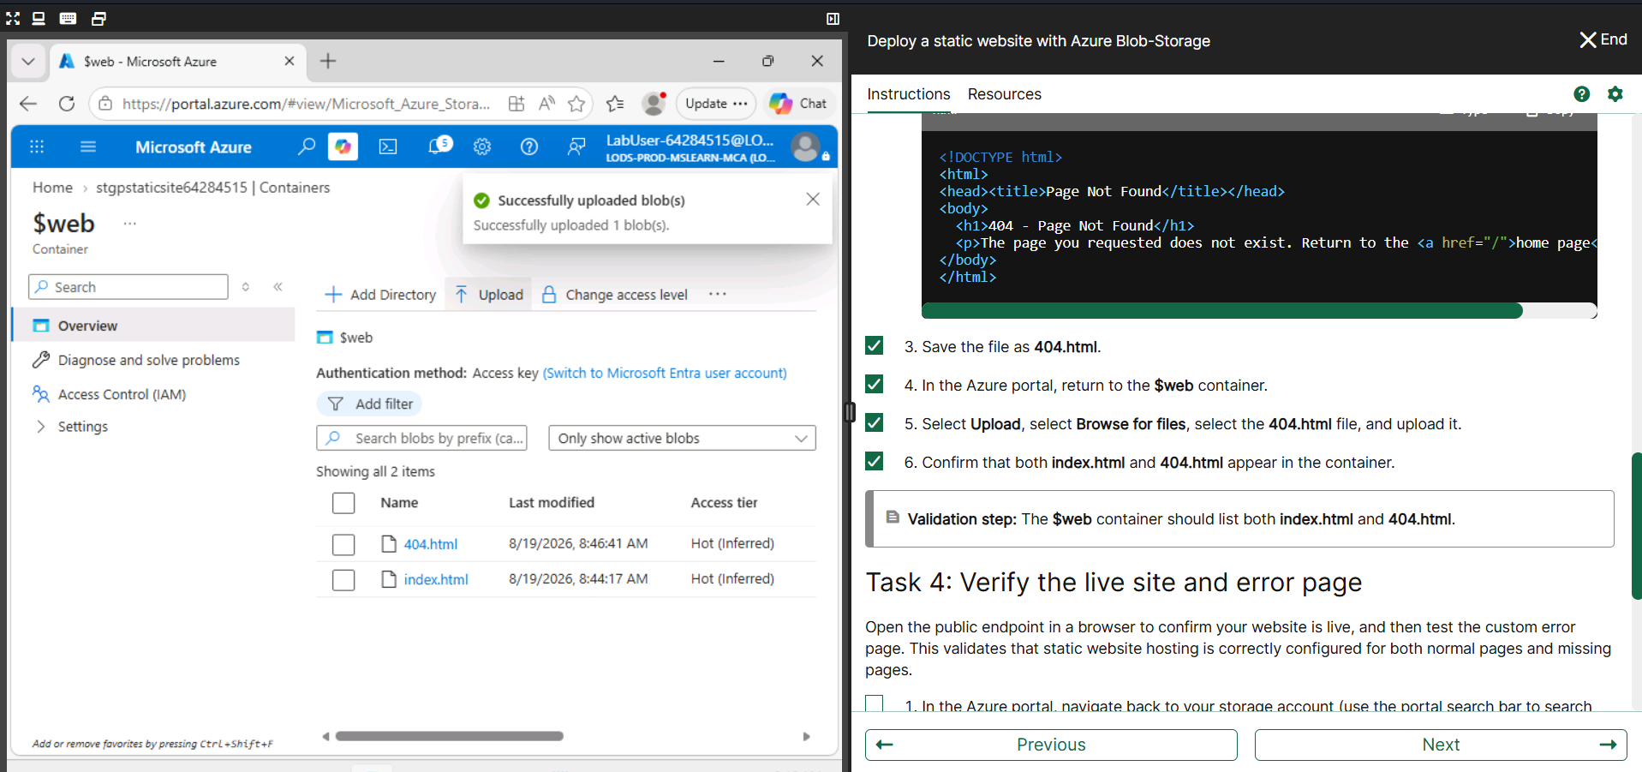
Task 5 — Verify Website and 404 Page
- Open the Primary endpoint from Static website settings.
- Verify that the main webpage is displayed.
- Enter a non-existing path such as /fakepage.
- Verify that the custom 404 - Page Not Found page is displayed.
Observation: This verifies normal website access and custom error handling.
📸 Screenshot 1 — Practical Evidence
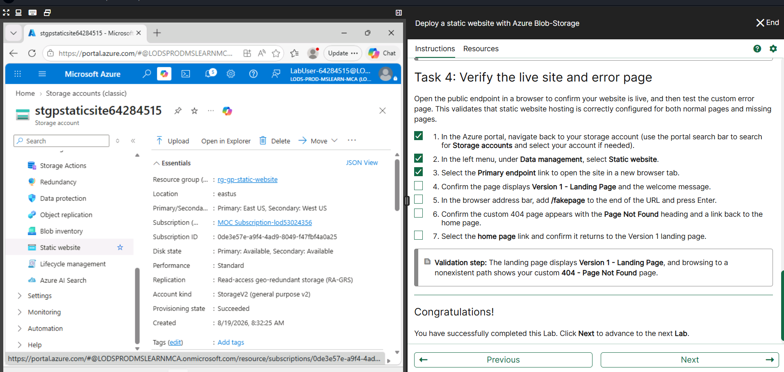
📸 Screenshot 2 — Practical Evidence
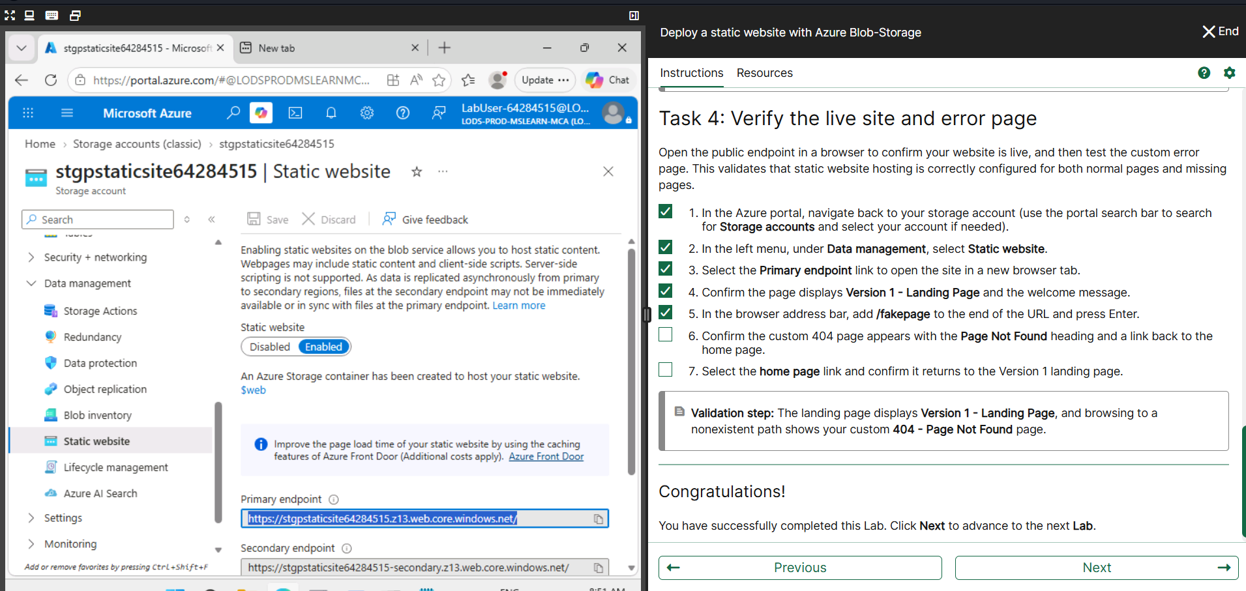
📸 Screenshot 3 — Practical Evidence
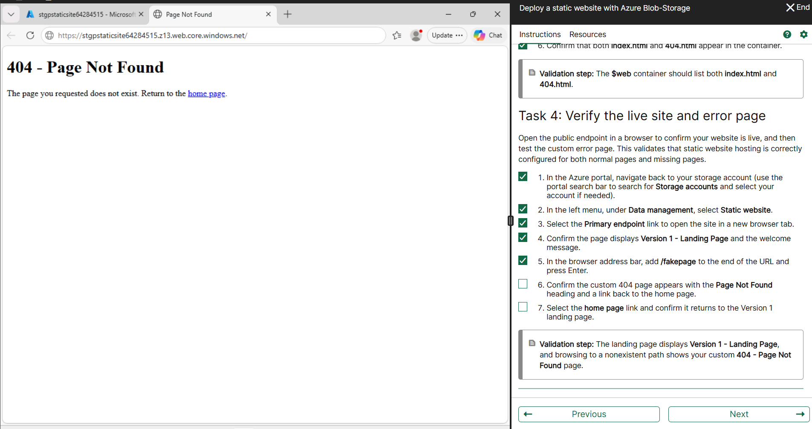
Task 6 — Update Website Content
- Modify the existing index.html and save the updated file.
- Upload it again to the $web container and enable Overwrite if required.
- Refresh the Primary endpoint and verify that the updated page is displayed.
Observation: Uploading the updated blob replaces the previous content and the website shows the new version.
📸 Screenshot 1 — Practical Evidence
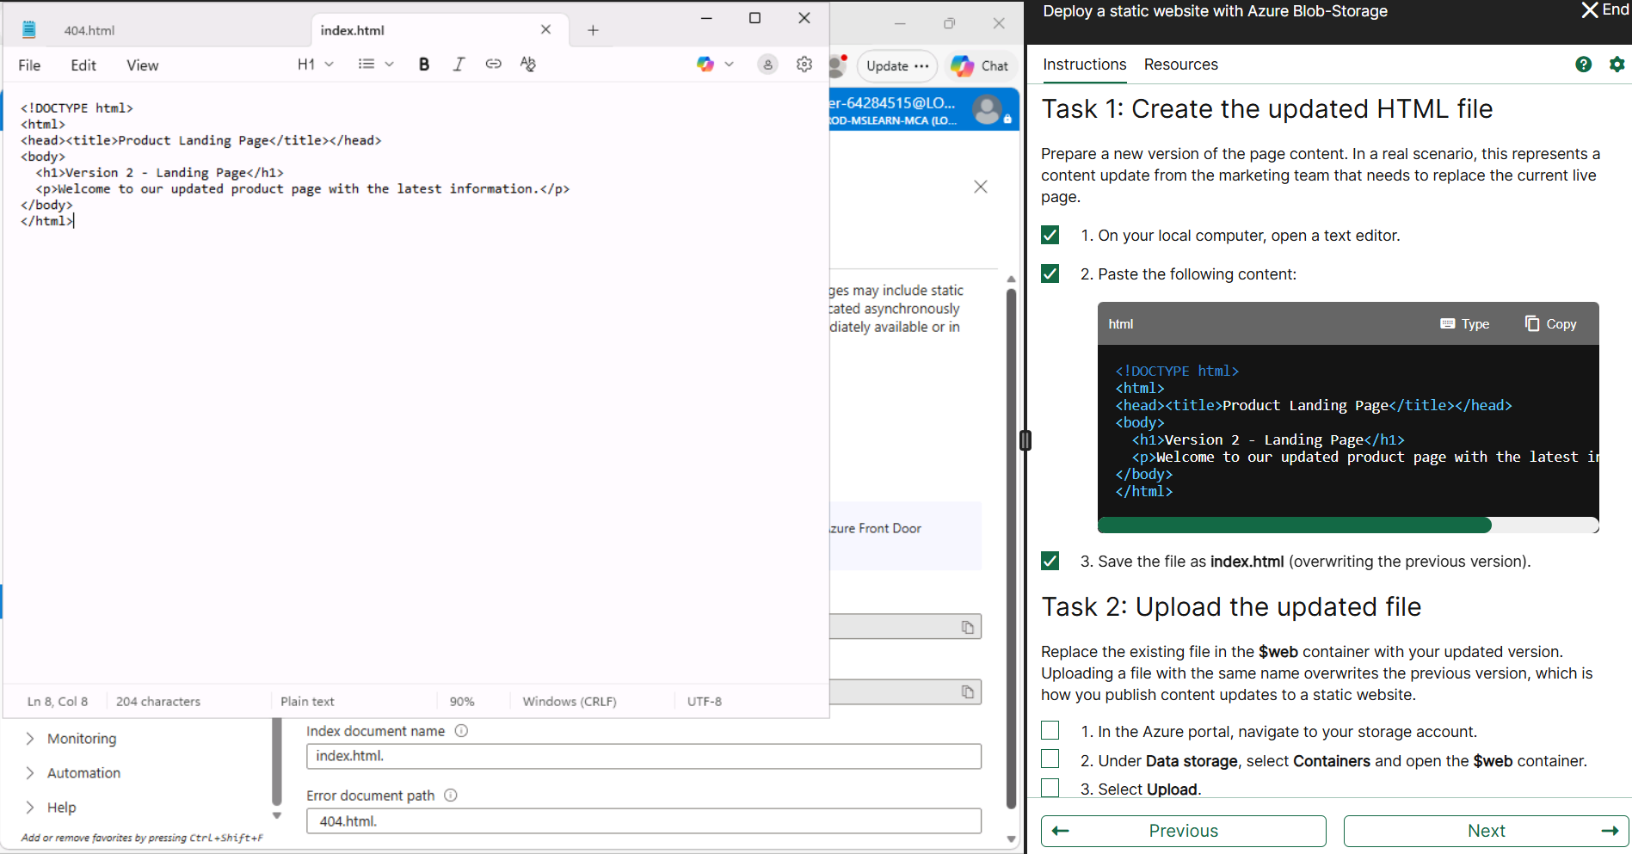
📸 Screenshot 2 — Practical Evidence
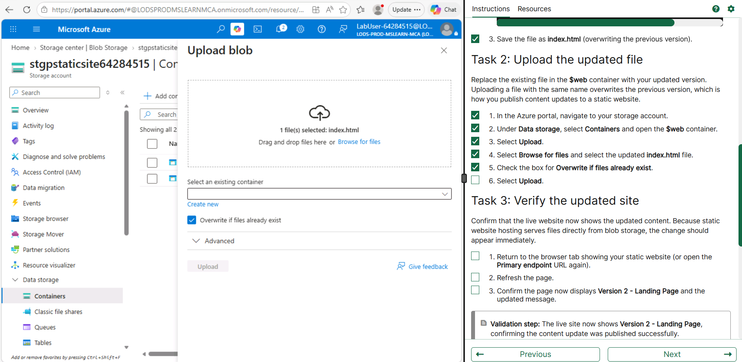
📸 Screenshot 3 — Practical Evidence
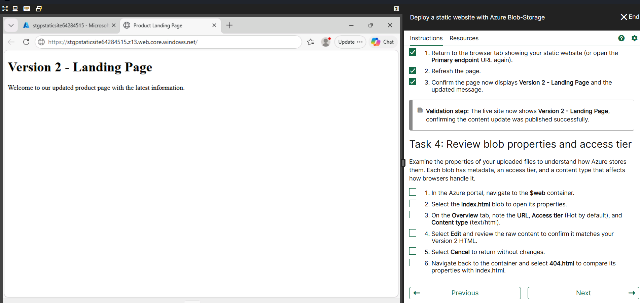
Task 7 — Review Blob Properties
- Open the $web container and select index.html.
- Review the Blob URL, Access tier and Content type.
- Verify the required values such as Hot access tier and text/html content type.
- Review 404.html properties if required.
Observation: Blob properties show how website files are stored and served.
📸 Screenshot 1 — Practical Evidence
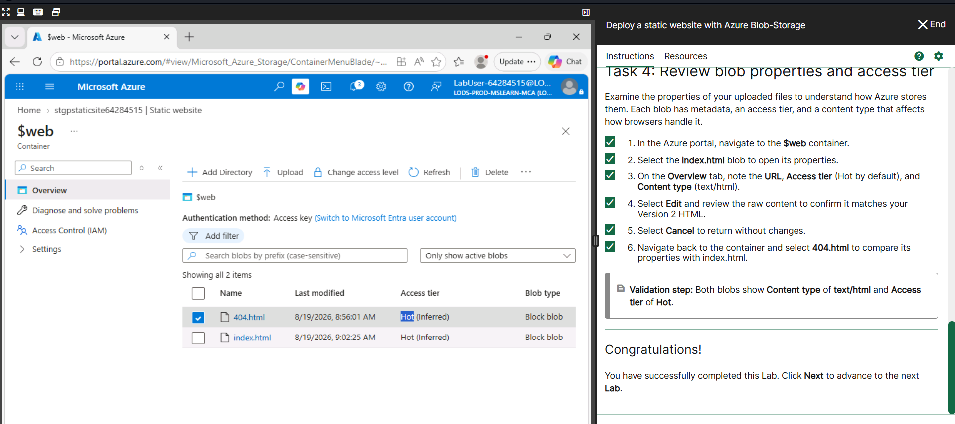
📸 Screenshot 2 — Practical Evidence

Task 8 — Cleanup
- Open Resource groups and select the practical resource group.
- Select Delete resource group and confirm the resource group name.
- Verify that the resource group is removed after deletion.
Observation: Deleting the resource group removes the resources created for the practical and completes cleanup.
📸 Screenshot 1 — Practical Evidence
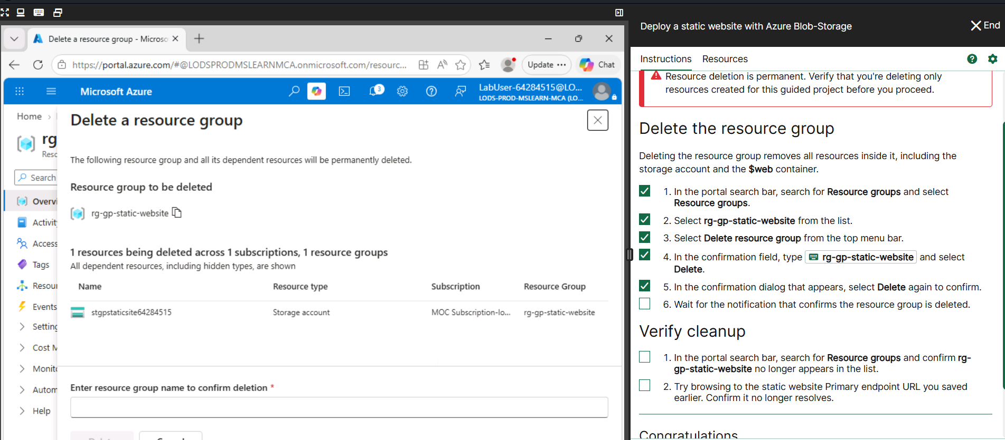
📸 Screenshot 2 — Practical Evidence
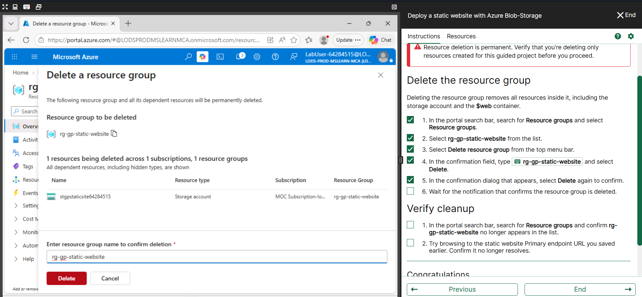
📸 Screenshot 3 — Practical Evidence
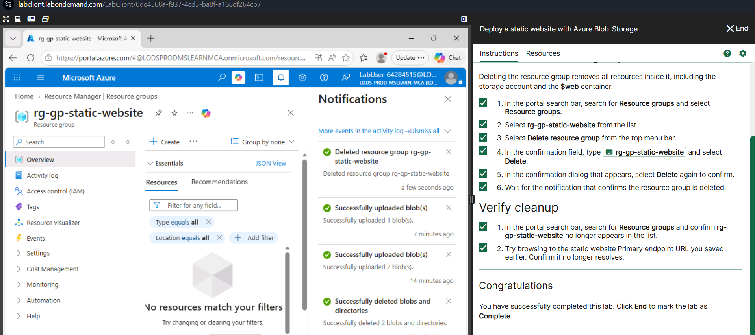
4. Result
The static website was successfully deployed using Azure Blob Storage. The website was accessed through the Primary Endpoint, the custom 404 page was tested, the website content was updated, and the required blob properties were reviewed. The resources were then cleaned up.
5. Conclusion
Azure Blob Storage provides a simple method for hosting static websites using the $web container and Primary Endpoint without managing a traditional web server.

